**Name of App:** Furbalicious

**Associated Views:**

* Login: Allows the user to login
* Registration: Allows the user to make a new account
  + Email Confirmation: Includes the system for confirming an email address
* User Profile: Allows the user to change their account information
* Order History: Displays all previously bought items
* Home/Catalog: Allows the user to shop for Furbies and add them to cart.
* Shopping Cart: Keeps track of Furbies added to the cart
* Checkout: Allows the user to “buy” their furbies

**Description:**

Furbalicious is an exciting upcoming new website that enables users like you to indulge all your Furby related dreams and nightmares. Here at Furbalicious, we maintain only the highest quality stock of Furby products, shipped directly to your door!

Furbalicious will make use of several key systems which this document will briefly outline. The first major system is the inclusion of user registration and authentication systems, to keep track of user identifying data. This data will be utilized to connect people with products that they might purchase. In addition to user authentication, Furbalicious will make use of an email system that allows users to confirm their account, as well as to send them emails related to making purchases. All user information can be edited after creation through the User Profile page.

For the Furbalicious catalog, Furbalicious will have a page displaying all Furby products with options to filter and search the catalog. Once a desired Furby is found, a user will be able to add that Furby to a Shopping Cart, which will keep track of all the desired Furbies. Once the Furbies have all been added to the cart, a user will be able to enter mock payment information to complete their purchase. This purchase information will then both be sent in an email to the user, as well as be stored within the Order History page for the user’s review.

**Database Tables:**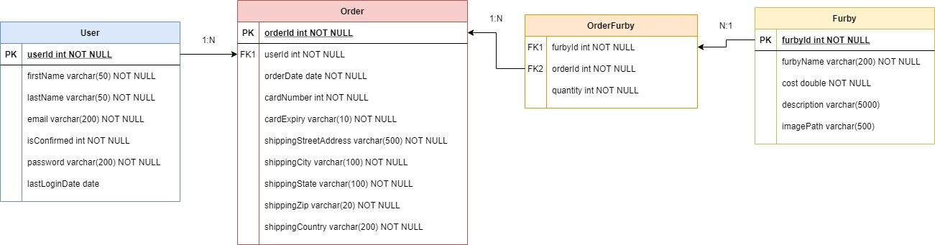

MOCK DRAWINGS OF VIEWS:

